**241/4**

**HISTORY**

**Paper 4**

**Jul/Aug 2016**

**2 Hours**

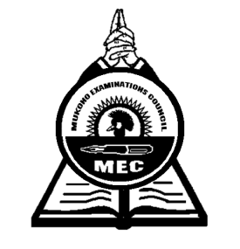

**MUKONO EXAMINATIONS COUNCIL**

**Uganda Certificate of Education**

**HISTORY**

**(South Africa)**

Paper 4

**2 Hours**

**INSTRUCTIONS TO CANDIDATES**

* *Answer* ***four*** *questions*
* *All questions carry equal marks*

1. a) Explain the origins of the Nguni-Tsonga peoples of South Africa. ***(10marks)***

b) Describe the Political and economic organization of the Bantu before AD 1850.

***(15marks)***

1. a) Why did the Dutch settle at the Cape between the 17th and 18th centuries? ***(13marks)***

b) What problems did the Dutch settlers face? ***(12marks)***

1. a) Why was there the 1836 Vegkop battle? ***(13marks)***

b) What was the impact of this battle on the people of South Africa? ***(12marks)***

1. a) How was Shaka able to build a powerful Zulu kingdom? ***(15marks)***

b) What led to the collapse of the kingdom? ***(10marks)***

1. a) Why were African independent churches established in South Africa during the 20th century? ***(12marks)***

b) How did these churches affect the lives of Africans? ***(13marks)***

1. a) Explain the causes of the 1880 – 1881 Anglo- Boer war. ***(13marks)***

b) How did this war affect the peoples of South Africa? ***(12marks)***

1. a) Why did the Germans occupy South West Africa in 1884? ***(13marks)***

b) How did this occupation affect the Nama and Herero? ***(12marks)***

1. a) Why was the Apartheid policy applied in South Africa between 1948 and 1990?

***(13marks)***

b) How did United Nations Organization (UNO) assist in the liberation of South Africa?

***(12marks)***

***End -***